**KURAL SCOOL OF DESIGN**

Where knowledge meets service minds

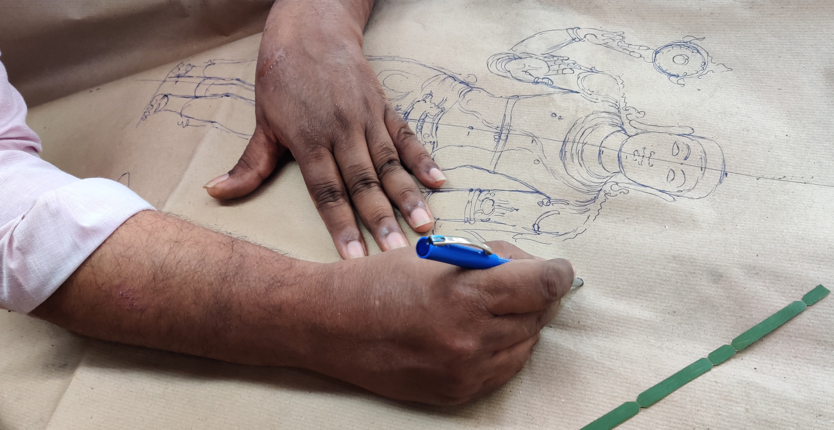

ABOUT US:

Kural foundation is a startup under SHRI – DST with a multi-disciplinary team working to elevate the originators of Tamilnadu by supporting and designing with them on the field. Kural has its roots extended not only to the design field but also onto the technical domain by establishing Dhakshakalam – Artisan's prototype development center with facilities such as casting center, 3D scanning & 3d printing lab and AR/VR Lab

Kural school of design has grown with the vision of tacit knowledge transfer between craftsman and designers for a better artistic society. With the informal teaching for 2 years, kural team started the school of design which has its motto to kindle the designer in everyone. Kural school of design assures to walk with students on every step to guide them and be supportive in both technical and design aspects.

With best tutors to lead the students on a right path and state of the art facilities to support students on all technical level, Kural school of design is on its designated stride in bringing out the creative designers with strong knowledge on fundamentals in designing.

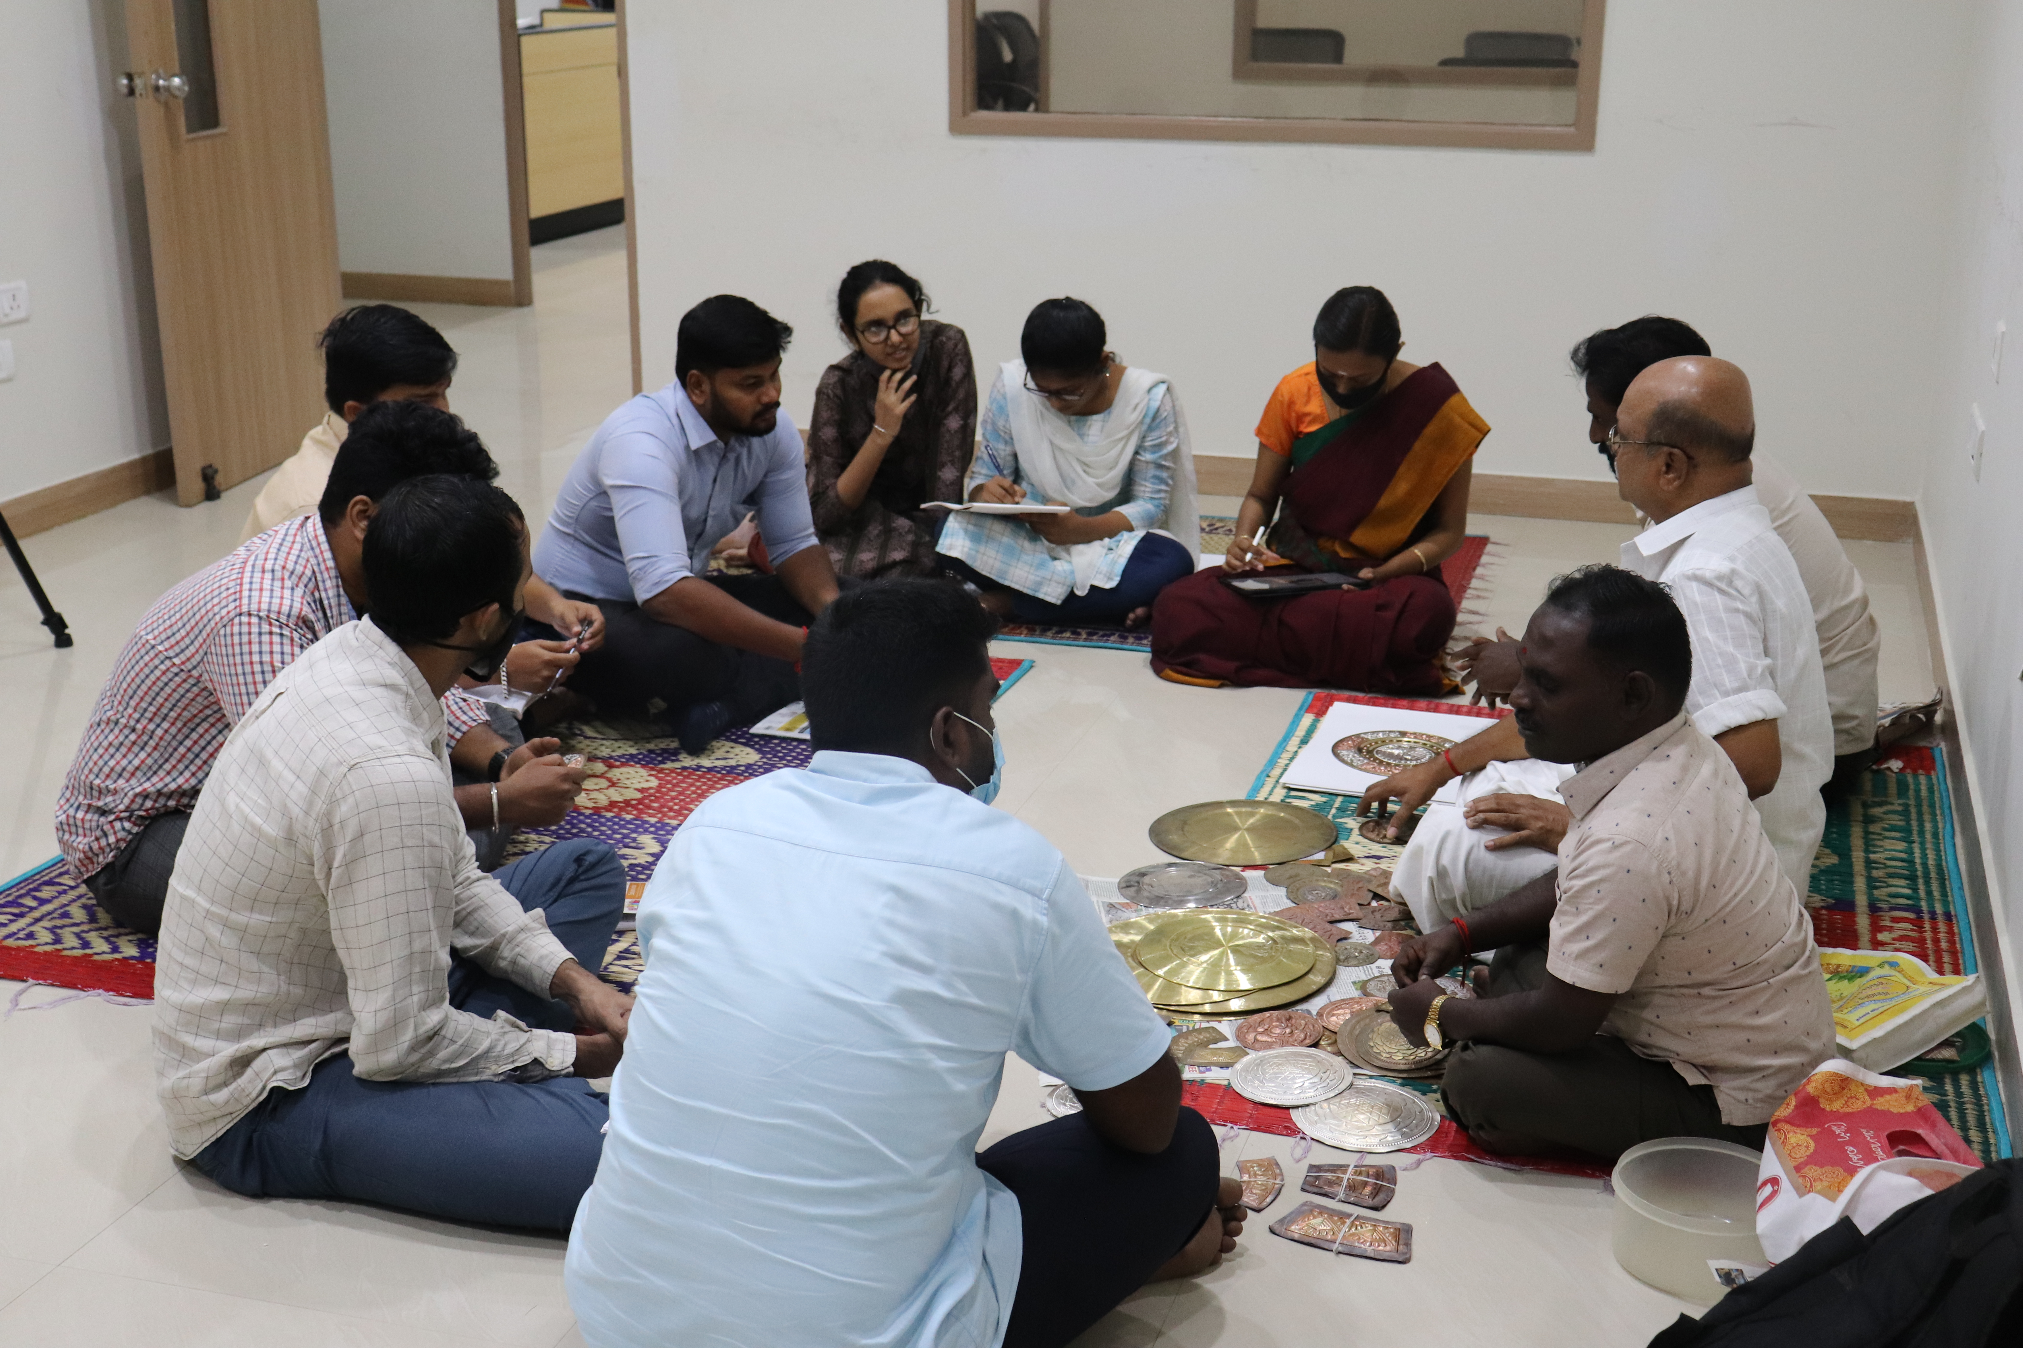

**WORKSHOP**

**Tacit knowledge transfer**

**5-day workshop with artisans on art plate making process**

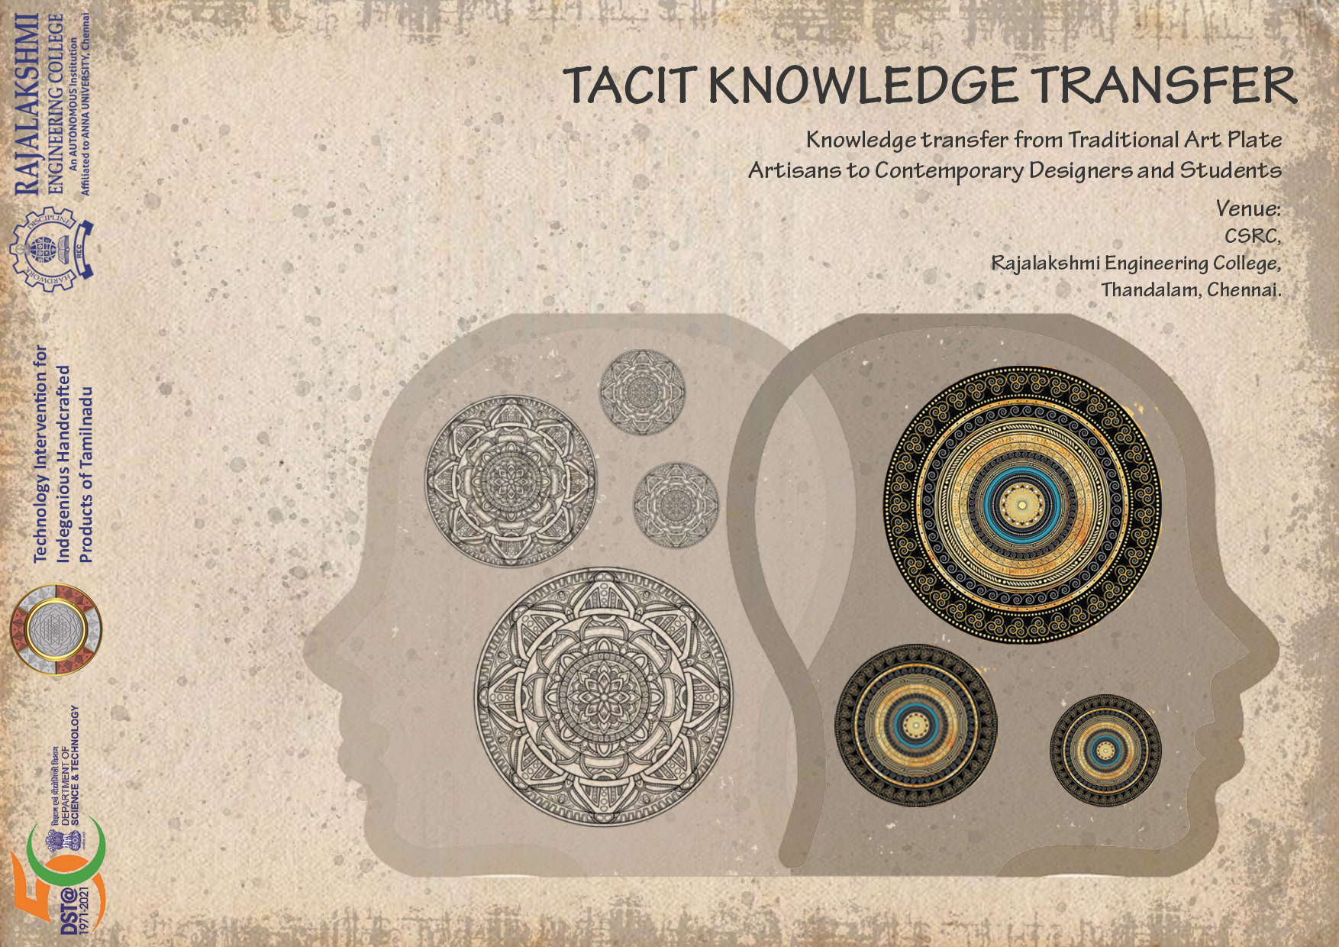

View more - content

“Knowledge speaks; Wisdom listens”. Art based knowledge is passed through generations but the lineage has broken due to shift in the modern world. Retrieving our native crafts is the need of the hour. Kural school of design has taken the initiative to gain tactful knowledge by understanding the innovative craft with architects, students & other professionals from Rajalakshmi school of architecture.

We are fortunate to have craftsmen from Thanjavur Mr. Shankaran J, Mr. Kumar and Mr.Kadhirvel who had spent their valuable time for us to understand the nuances of our heritage craft. Tacit knowledge transfer is a 5-day workshop on detailed demonstration from the artisans on the why and wherefore of art plate design principles. It was all started with the discussion on art plate and its making techniques for the students to have a basic knowledge.

A contemporary art plate design from kural studio team was shown from the scratch and students gets to explore the different stages involved in making of art plate. Also, research team were engaged with utmost dedication and came to know the complications and other struggles faced by the artisans. Tacit knowledge transfer workshop was admittedly useful in developing the power tool by understanding the hand usage and movements on a technical aspect.

As the outcome of tacit knowledge transfer, Research team progressed on ergonomically designed furniture by analyzing the work culture and posture of artisans. Conceptual design was then developed and materialized in a best way possible. The team took effort in designing the furniture to attain comfort and to assure healthy work environment for the artisans. Furniture design has gone through its own iterations and the end product was safely delivered to artisans. Now the developed furniture was used in artisan's workplace in a full bloom.

**Acoustic workshop**

**3-day hands on workshop on acoustical treatment using ethnic fibers**

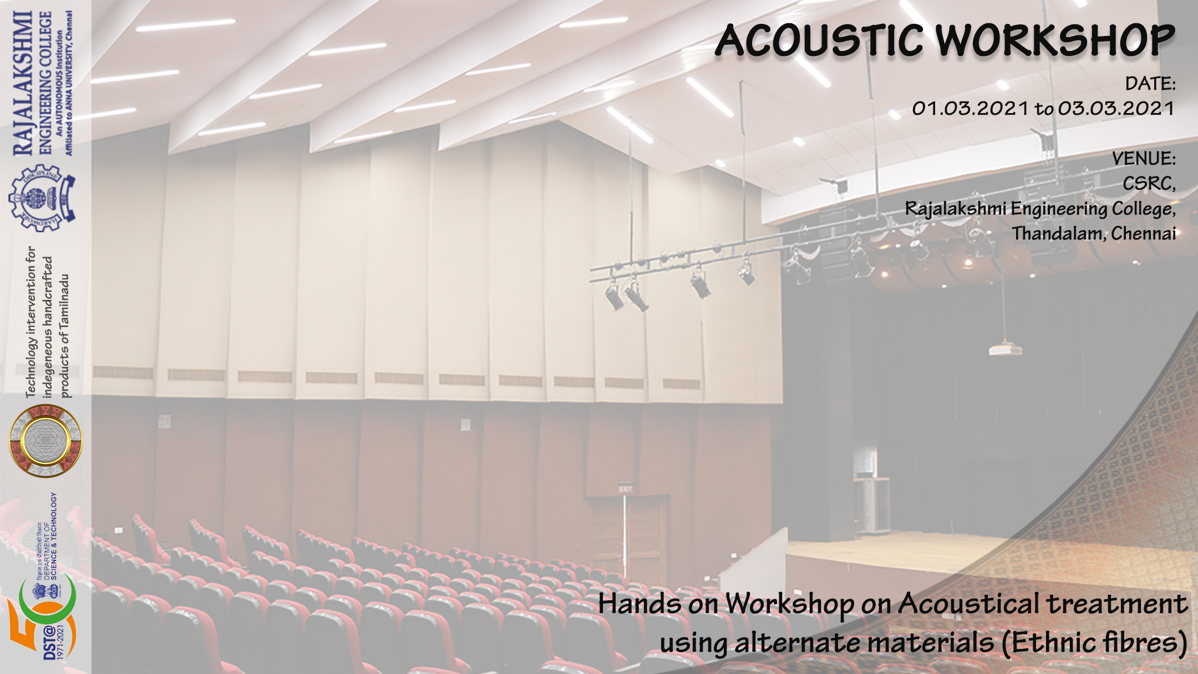

View more - content

Hands on acoustic workshop on acoustical treatment using ethnic fibers was conducted on 1st of march 2021. Third year students of Rajalakshmi school of architecture & other interested professionals played a main part in making the workshop a success. After experimenting with pattamadai mat as an acoustical treatment, Kural research team delivered their research output to the students for them to have wider knowledge on acoustical property of natural materials.

Not only the acoustical property of pattamadai mat was explained, Dr Kalaiselvi has given a lecture on making process of acoustic wall panel with ethnic fiber. Fabrication of wall panels and fixing process of same were demonstrated by the assigned workers. Students were got to explore more on structural and technical details of acoustic wall paneling.

For more involvement of students, a design task was introduced to develop a wall panel design using ethnic fiber and the brainstorming session was conducted next day to discuss more on design development and acoustical design of a space. Some students were involved in fabric paneling on site with the help of workers.

As for the ceiling treatment, students pitched in their ideas on ceiling panel design. Kural team came up with acoustical ceiling clouds using pattamadai mat as a technical intervention and the design was an output from exploring rhino & grasshopper software. Even though the research team has finalized design on ceiling treatment there are some challenges faced during execution. Students & designers get to explore more on site and had fun in completing the ceiling treatment too.

**Furniture Making Workshop**

**3-day hands on workshop on furniture design and prototype making**

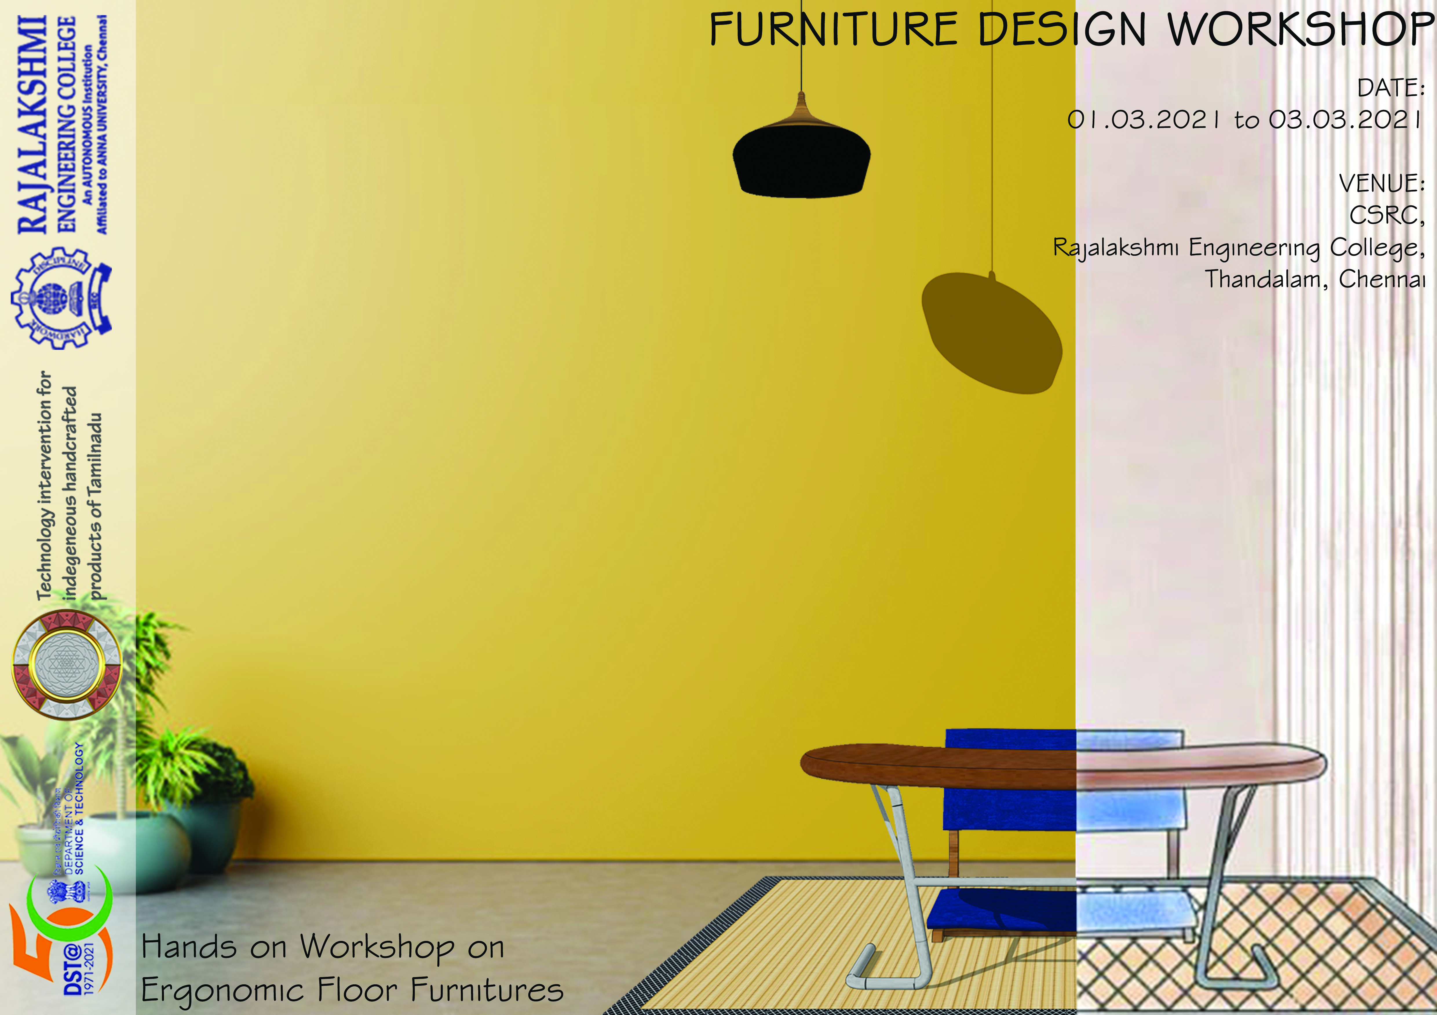

View more - content

3-day Hands on furniture making workshop was held on 01.03.2021. A workshop to demonstrate the making process of furniture was explained to the 2nd & 3rd year students of Rajalakshmi school of architecture. The main aim of the workshop is to give students a wide knowledge on ergonomic measurements involved, details of materials & finishing techniques. Research team has worked on field with the workers to bring out the best product they’ve designed.

Dyana irukkai – a floor cushion with pattamadai mat as a cover is designed by the research team. With the hands on from the student Nandhini who is very keen on working on the field, sat with the workers and completed the product without much help. They also made even more interactive by taking photographs of said floor cushion with student as a model and thus adds a wonderful memory to our gallery.

Other furniture which was designed for particular work group was also explained to the students and they get to watch the prototype development from the scratch. Furniture making workshop is a huge success which helps in delivering the furniture to artisans' workplace on time.

**Furniture Designing Workshop**

**Online lecture on ergonomic design development of furniture**

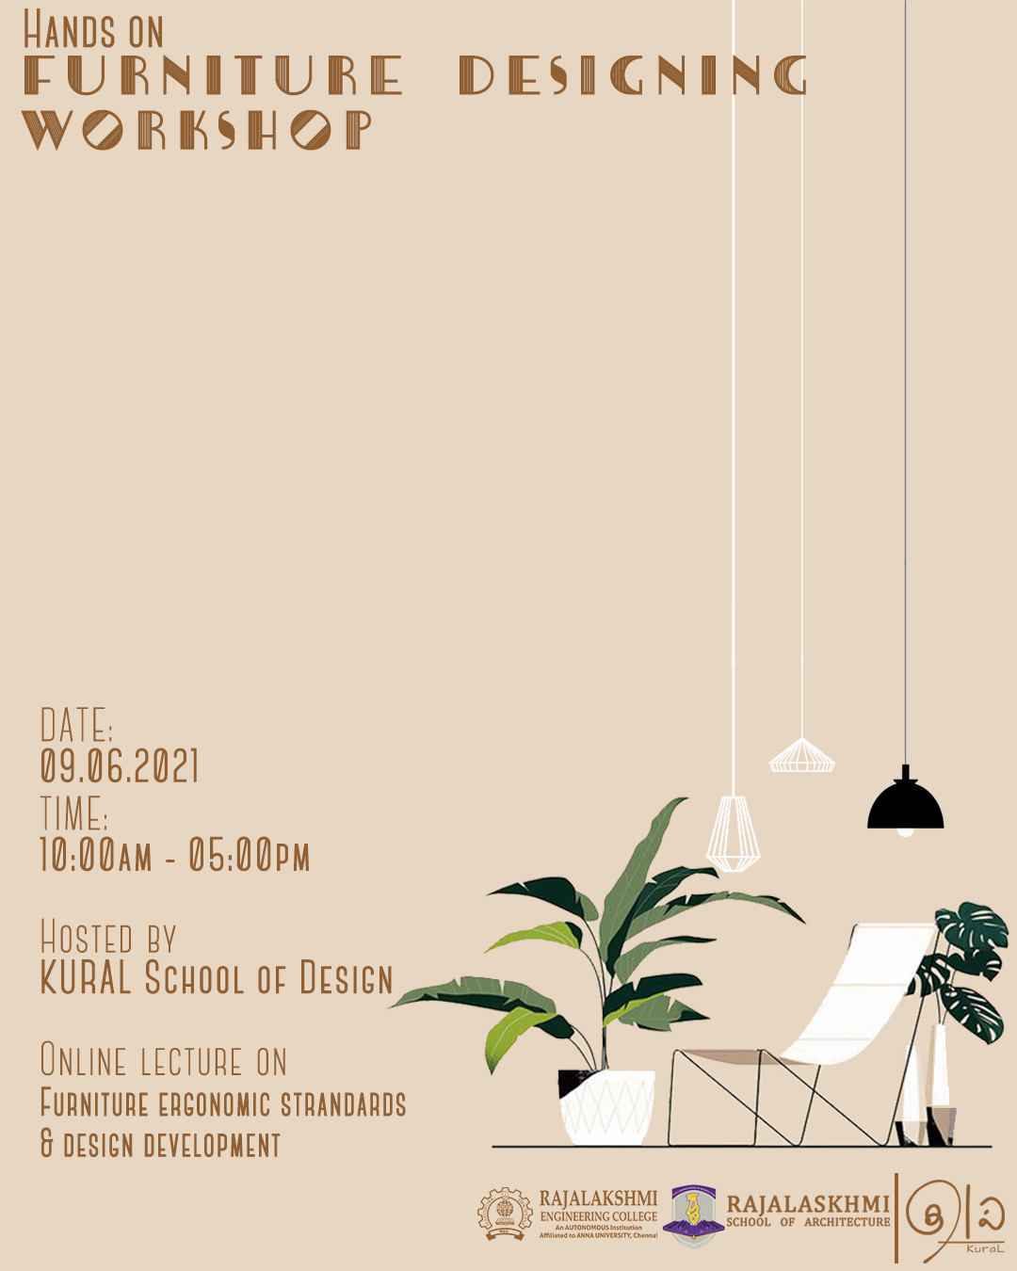

View more - content

Designing Furniture has been advanced from the Traditional wood-based furniture to the Modern 3D printed furniture. But the term Ergonomics has lost its integrity in the field. To hike productivity of a healthy environment, Ergonomic furniture design is a vital demand. We integrated this Workshop with Hands On session besides online lectures & standards as it ends up with a conceptual design development from students.

Understanding of “why furniture designing plays a major role” is the main vision of this online lecture. We conducted this workshop for the 1st & 2nd year students as they’re the future designers, it is mandatory for them to know the importance of furniture designing. Workshop lecture was started with overall view on furniture design and why furniture designing is outspoken a lot in architecture field. Ar. Gauri S Lal has given a lecture on the said topic in a best way for better understanding. A fun activity was given to the students and their involvement in design learning made the workshop much more interesting. A design which was submitted by the students were also good and the team get to develop new furniture to add it in their catalogue

Ergonomics and anthropometrics play a vital role in designing a furniture. Basic principles in ergonomics and floor furniture anthropometry were explained in a short and brief way by Ar. Asmaa H which was very helpful for the students in conceptual development stages of design. Brainstorming session by Dr.Kalaiselvi is also included to explain about the informal work sector and their work culture. Followed with furniture design development for artisans with respect to their culture was presented by Ar.Rakhshana to give a wider knowledge on design process of furniture making. Students get to know the different work cultures of tamilnadu and the challenges faced during fabrication is also explained.

Workshop concluded with discussion session on the conceptual design developed by the students. Many interesting ideas were came into spotlight and students explored more on conceptualizing a furniture design which was the ultimate goal of furniture designing workshop.

**COURSE DETAIL**

A specialized online course for 6-month to master design thinking. Learn human centered approach empathizing user perspective on products with rapid prototyping & fabrication techniques.

**WHY DESIGN THINKING IS NEEDED?**

“A problem well stated is a problem half solved”. This is a powerful yet simple paradigm applicable in every field. Design thinking enables you to do ‘more with less’. It trains your mind to arrive at your answers in a systematic and structured approach.

**WHO SHOULD ATTEND?**

With no boundaries to imagination, any graduate – architect, designer or an engineer - desiring to create and yearning to invent, befits the course.

**PROGRAM EXPERIENCE**

Month 01 – Learn fundamentals & principles of 2D & 3D. Understanding of concept of color theory

Month 02 – Learning on Culture & society-oriented design. Universal design and inclusive design concepts. Introduction to innovative design & design thinking

Month 03 – Study on Materialistic approach on products with ergonomic standards.

Month 04 – Learn toy designing, product detailing & prototyping. Introduction to 3d scanning & printing techniques.

Month 05 – Understanding of financial aspect of product development and rapid prototyping.

Month 06 – Exploration to Entrepreneurship and patent filing. Portfolio designing techniques

**OUTCOME**

Master your design thinking mind and enlarge your skills on product development with financial and user-centric approach

**Dakshakalam:** Artisans& designers prototype development center. An equipped establishment to cope up with the latest technology to develop prototypes

**VR/AR Lab:** Laboratory for our virtual & augmented reality features that adds on to the world's near future.

**3D scanning**: Scanning center of real objects that would be digitized to make modelling much more efficient.

**3D printing:** Printing facilities for the 3D objects that keeps on layering with the computer aided Visualization.

**Design Studio:** Where creative mind fusion happens between diligent artisans and neoteric designers for exquisite products

**Casting center:** workshop where our artistry ideas comes into an outstanding product with the purposeful function.

**FACULTY:**

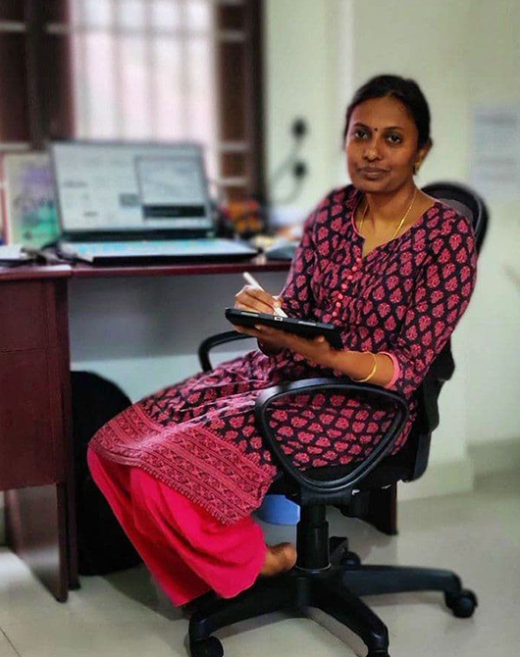

**DR KALAISELVI R**

**IIT Madras – Major on architectural acoustics**

Professor leading the research team for the past two years with 16 years of experience & immense knowledge in designing field. She is an expertise in fundamentals and open towards exploring a lot in product designing. She is an ace in solving issues on field with a simplest & coolest way possible. She is also good in understanding the perspective of students and will analyze the working capacity to motivate students individually.

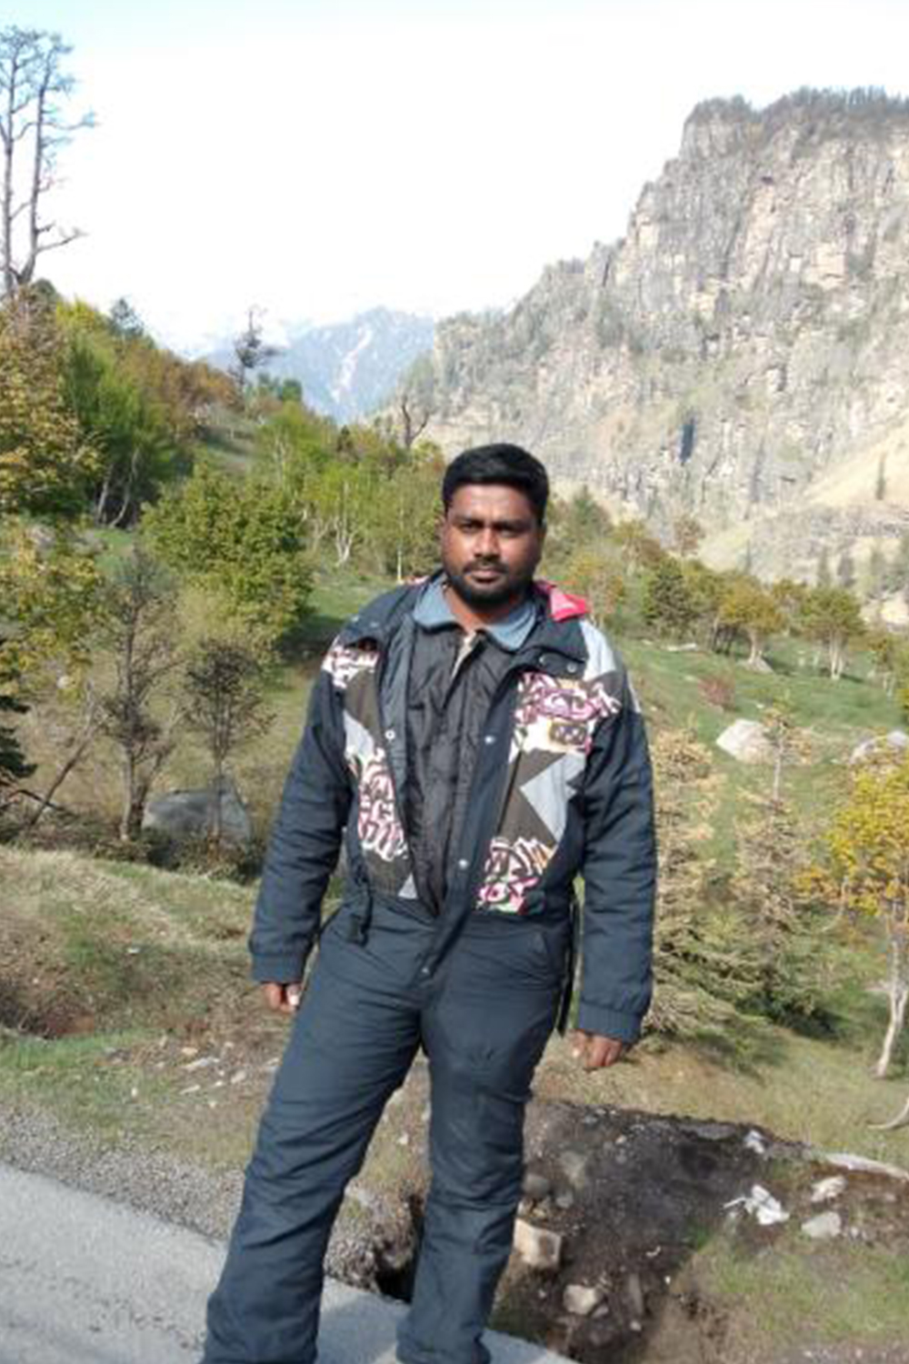

**ER VINOTH KUMAR**

**Mechanical engineer - CADCAM & Reverse Eng. specialist**

Professor marching the team towards a successful path by supporting and guiding them on innovative solutions with his proficient engineering skills. He is very attentive in solving the issues on technical terms which is a key point in innovative product development. His knowledge on technical equipment design will serve as a paved path for the students who are ready explore on tool development.

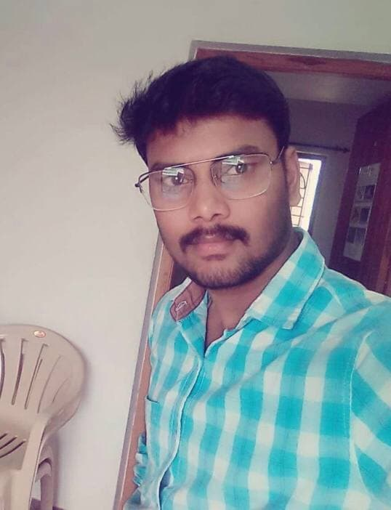

**ER JAYAGANESH**

**Aeronautical engineer**

Research scholar, CEO of engineering solutions, Lecturer – A multi-talented diplomate specialized in technical aspects of product developing. He contributes towards the research by developing handy power tools with keen observance on artisans work culture.

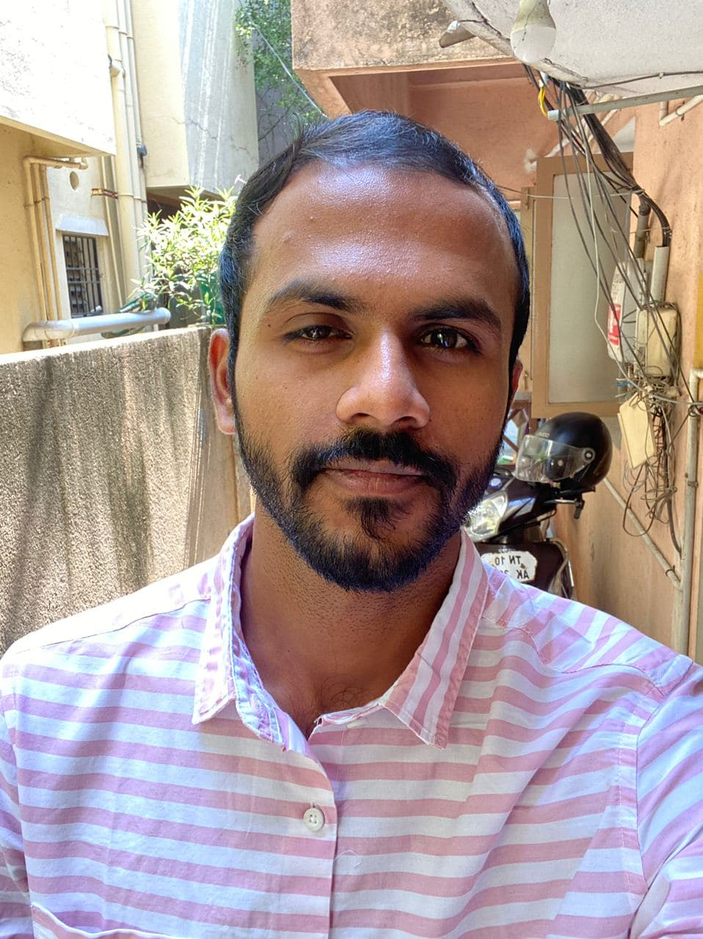

**ER ARAVIND PRASAD S**

**Master degree in mechanical engineering**

He is Passionate towards delivering industry ready and skill development training for students. With his 2+ years of experience in startups on core domain knowledge in fields of 3D printing, 3D scanning & Reverse engineering, he will train the students in a calm and composed way.

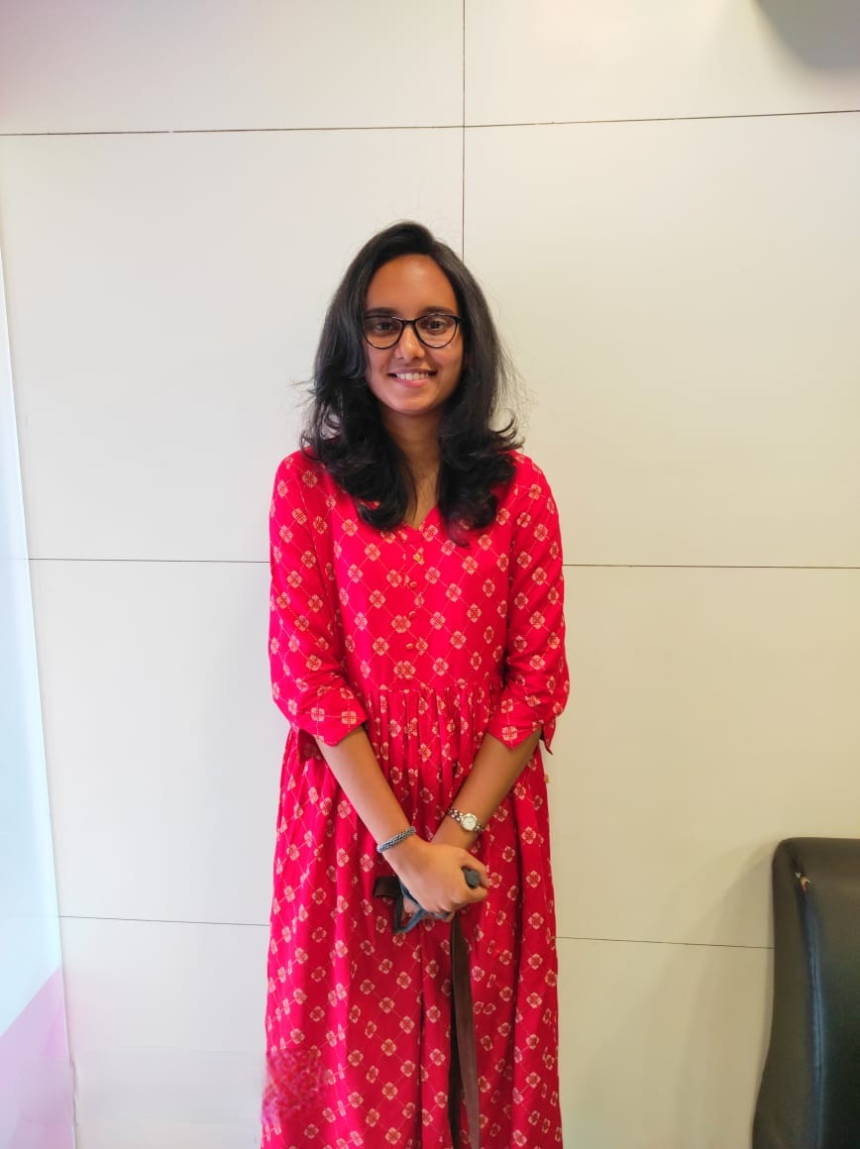

**AR ASMAA H**

**Architect**

Architecture graduate with 4 years of experience in designing field. Currently working as a research scholar under kural team. Her thirst for gaining knowledge always keeps the team enthusiastic with her presence. She is an expert in ergonomic & universal design and trains the students in product design standards, which will strengthen their base.



**AR GAURI S LAL**

**Architect, NIT Calicut alumni**

Architect with 3 years of experience in architecture field, having worked at L&T Construction, (Chennai) and Lal Associates (Kochi). She is also very passionate about furniture design, toy design and values attention to detail as the utmost important merit to designing and problem solving. Her way of teaching is always fascinating for the learners, keeping the students on track for the whole lecture.

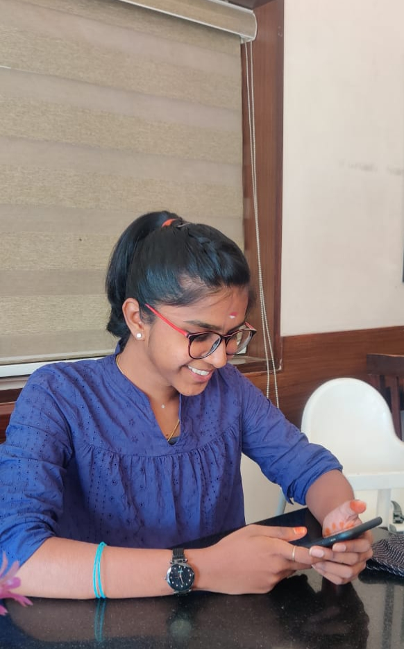

**AR RAKHSHANA T**

**Architect**

Architect working in the field of research and designing. She is fond of designing furniture on informal work sector She has evolved striking designs. Rakhshana is a sublime furniture designer who has developed notable furniture design for the native craftsmen.

**FAQ**

**Why this course is advisable for graduates rather than students?**

To understand the concept of design thinking and product development, students must have a preliminary knowledge on how day-to-day products works. This course will help you in applying the fundamentals on real day products. This course may act as a bridge for graduates to reach better career opportunities with the skills learnt in course period. This course also aims to train the students with an independent business mind.

**What skills will I learn in this course?**

Mastering the creative thinking mind is a main motive of the course. Graduates of this course will emerge as an expertise in prototype development with management and financial handling skills. With the exposure towards 3D scanning, modelling and printing students will get an overall knowledge on rapid prototyping and materialization. Students will also gain more knowledge on social & context-based design principle. UX / UI design will also be a added advantage on their career path.

`